Введение

…

Аналоги

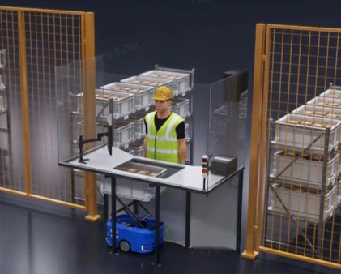

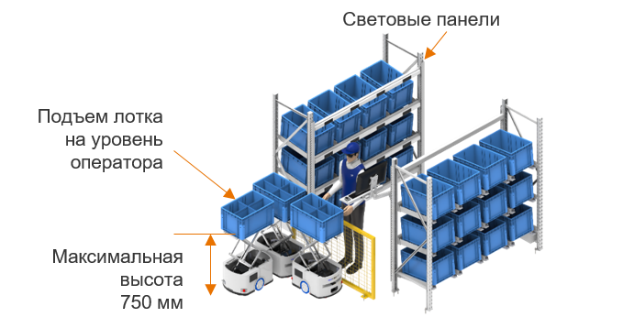

<https://axelot-tech.ru/products/resheniya-i-oborudovanie/avtomatizirovannye-resheniya/roboty-acr-amr-agv/roboty-acr/>

11.10.2024

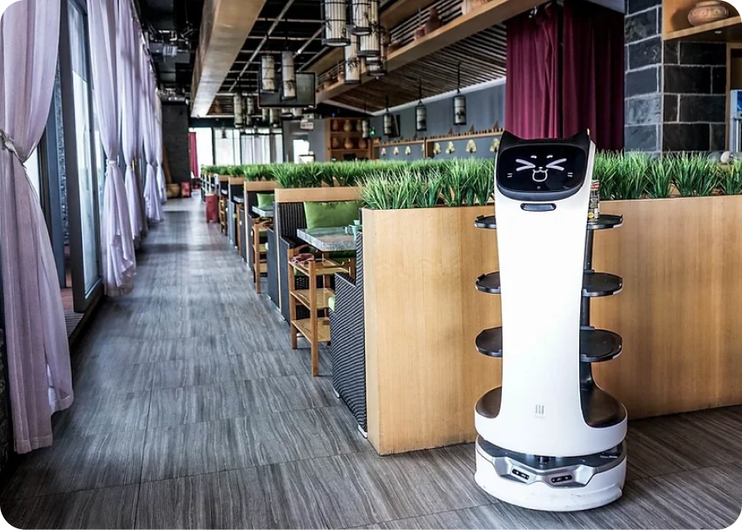

<https://robosobaka.ru/products/robots/servisnye-roboty/pudu-bellabot/?utm_source=yandex&utm_medium=cpc&utm_campaign=112808912.general_search&utm_content=16350098393&utm_term=---autotargeting&etext=2202.nRqG7DngpprI4dD7dQ_vm0Msbb36sVu4C1ibYy-YDraKj3NZ5xWwnTNmwBVV5fwJbGN0a3V1Y3BiY2djdGJ5Yw.7e7d9e8b3669b0f49e3e429c404b7ea97268a4da&yclid=14147834142892228607>

11.10.2024

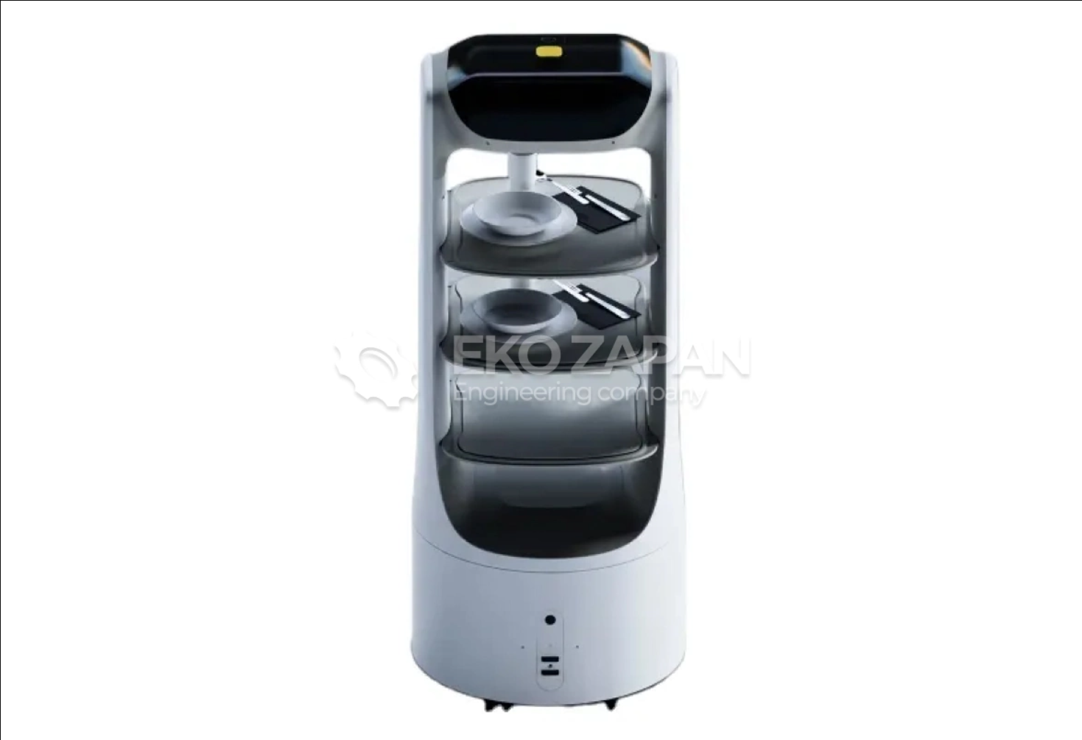

<https://ekozapan.com/avtomatizacziya-proizvodstv/robot-oficziant/robot-oficziant-s-ii-i-avto-zaryadkoj.html?etext=2202.nRqG7DngpprI4dD7dQ_vm0Msbb36sVu4C1ibYy-YDraKj3NZ5xWwnTNmwBVV5fwJbGN0a3V1Y3BiY2djdGJ5Yw.7e7d9e8b3669b0f49e3e429c404b7ea97268a4da&yclid=9366934288093413375>

11.10.2024

<https://marketing.rbc.ru/articles/5887/>

20.01.2025